DTS Visual Diary

Table of Contents

Minimum Requirements: 1

What The Program Is About 1

What Will The Style Of The Quiz Be? 2

How Will The Data Be Stored? 3

How Will Structure Your Data? 3

How Will I Give Feedback To Users? 3

Questions 5

Start 5

Barebones Working Code 9

Added The 10th Question + Made A Ending To The Game 10

Added A Bank Ballance With The Ability To Save And Accumulate Over Different Games With A Hidden To The User Reset Score Button 11

Added Colour To Answers 12

Added More In-depth Comments And new rules/game functions list 12

# Minimum Requirements:

* Min Ram 2gb
* Min 10gb Hard Drive Disk Space
* Min Operating System Windows 7, Mac OS, Linux

# What The Program Is About

Game Name: Who Wants to Be Homeless

To play Who Wants to Be Homeless?, you gotta pay an entry fee of 1 million dollars. Yeah, I know it’s a lot, but this game’s made for celebrities, so they can handle it. Plus, 70% of that money goes to charity, so it’s all for a good cause.

Once you're in, you’ll answer 10 questions with three possible answers: A, B, or C. If you get the question right, you win more money! Here’s how it works:

* Round 1: $100
* Round 2: $1,000
* Round 3: $300,000
* Round 4: $400,000
* Round 5: $500,000
* Round 6: $600,000
* Round 7: $700,000
* Round 8: $800,000
* Round 9: $1 million
* Round 10: $10 million

After each question, you get to decide: do you leave with the money you’ve won, or keep playing for a bigger prize? But be careful if you get one wrong, you lose everything!

In Round 9, you at least get your 1 million dollars back. If you make it to Round 10, you’ve got a shot at winning $10 million. So it’s all about whether you want to take the risk or walk away with what you’ve got.

Why Celebrities? The game’s for celebrities because they can afford to play, and it’s a fun way for them to raise money for charity. Plus, it’s awesome to watch on TV!

Example:

Imagine Taylor Swift plays. She pays the entry fee and starts answering questions. By Round 9, she’s got $800,000. Now, does she take the $800,000 and walk, or risk it for $10 million in Round 10? If she guesses wrong, she loses everything, but if she guesses right, she wins big

# What Will The Style Of The Quiz Be?

A timed multichoice question game with 10 total questions varying in difficulty and prize.

# How Will The Data Be Stored?

The data is stored in a variables format

# How Will Structure Your Data?

My data has been structured using if statements or variables

# How Will I Give Feedback To Users?

The user will receive feedback by a “print” prompt saying either “Incorrect” or “Correct” signifying if you answered the question correctly. You will also be given a score/prize after each round scaling the more rounds you get complete signifying you are doing good or bad.

Evaluation

my code went well because during testing i found next to no problems or errors this showed that the structure and logic of my code were solid and reliable i believe this was mostly because i used a high level of code and took my time planning out what i wanted to achieve this helped remove a lot of possible errors before they even happened i made sure to test each part as i made it which also helped catch anything early on looking back at my time spent coding i can say that choosing to focus on the project instead of playing games really made a big difference in how much progress i made and how focused i was on writing good code this boosted my overall work ethic and helped me stay committed to finishing the project properly. i also learned that staying consistent each day made it easier to avoid rushing causing mistakes.

in the future i would like to add a simple gui like easy gui to my game i think this would make it look and feel more finished and professional it would also improve how people play the game and help make sure there are fewer errors or confusion during playing. another improvement could be adding more features or making the game to keep it interesting for longer. this would make the project even better overall i’m really proud of how my code turned out it worked well and met my goals and showed how much i improved during the project i feel confident that with more time and practice i can take it even further and make something even more impressive.

Testing Table

|  |  |  |  |  |  |
| --- | --- | --- | --- | --- | --- |
| Date | Question | Input | Expected result | Actual result | Fix |
| 07/04 | Is This Your First Time Playing? | yes | Welcome to who wants to be homeless bank balance $1,000,000 | Welcome to who wants to be homeless bank balance $1,000,000 | NO Fix |
| 07/04 | Who was the nazi dictator  A,B,C | A | Correct | Correct | No Fix |
| 07/04 | Do you wish to leave with prize money ENTER “LEAVE” | LEAVE | Your Winnings This Game ---  Your Total Accumulated ---  Thanks For Playing! | Your Winnings This Game ---  Your Total Accumulated ---  Thanks For Playing! | No Fix |
| 07/04 | What Is Your Age? | Twenty | Invalid Input | ERROR! |  |
| 07/04 | Is this your first time playing? | 15 | Invalid Input | Invalid Input X999999999 |  |
|  |  |  |  |  |  |
|  |  |  |  |  |  |

User Testing

Aiden Prout: 13/05/25, It needs to have better spacing between the different lines in the question to make it easier to read. I like how you displayed the rules in a neat and organised way. I also like the addition of pickle which creates the leaderboard.

Max Naylor: 19/05/25, It is a good and challenging quiz, though it can be formatted better by adding a border or increasing the spaces between lines to make it look better. The leaderboard feature and the conservation of money across rounds is good Aswell.

Boundary Testing

|  |  |  |  |
| --- | --- | --- | --- |
| **Test** | **Input** | **Test Value** | **Expected Result** |
| 1 | Age | 12 | Rejected (Too young) |
| 2 | Age | 13 | Accepted (Minimum age) |
| 3 | Age | 74 | Accepted (Maximum age) |
| 4 | Age | 75 | Rejected (Too old) |
| 5 | Age | "abc" | Rejected (Invalid input) |
| 6 | Bank Balance | 999,999 | Rejected (Not enough to start) |
| 7 | Bank Balance | 1,000,000 | Accepted (Just enough to play) |
| 8 | Entry Input | "yes" | Game continues |
| 9 | Entry Input | "no" | Game exits |
| 10 | Entry Input | "maybe" | Rejected (Invalid answer, exits) |

Pseudocode

Ask the user Who was the Nazi dictator? (A) Hitler, (B) Osama Bin Laden, (C) Donald Trump

# Questions

If the answer is A or Hitler

Show Correct

Increase score by 100

Show current prize money

Ask user to press ENTER to continue

Ask if they want to leave by typing LEAVE

If user types LEAVE

Save the game

Show game and total score

Exit the game

Else

Show Incorrect you lost

Exit the game

# Start

loop until a valid age is entered

ask the user for their age

if age is greater than 13 and less than 74

allow them to play

break the loop

else

tell them they cannot play

exit the program

if the input is not a number

show an error message

define a function to save the game

if a saved game file exists

try to load the score from the file

add the new score to the old one

else

just use the new score

save the updated score back to the file

return the total score

define a function to load the game

if a saved game file exists

try to load and return the score

else

return zero

ask if it is the users first time playing

loop

if the user enters zero

reset the saved score to zero

show a reset message

exit

if the user says no

load the score from the file

break the loop

if the user says yes

give them one million dollars

break the loop

else

show invalid answer and exit

show a welcome message

show the current bank balance

ask if they want to pay one million to play

if they agree

if they have less than one million

tell them they cannot continue

exit

else

start the game and reset score to zero

if they say no

show exit message

exit

if input is invalid

show error and exit

Code WOF:

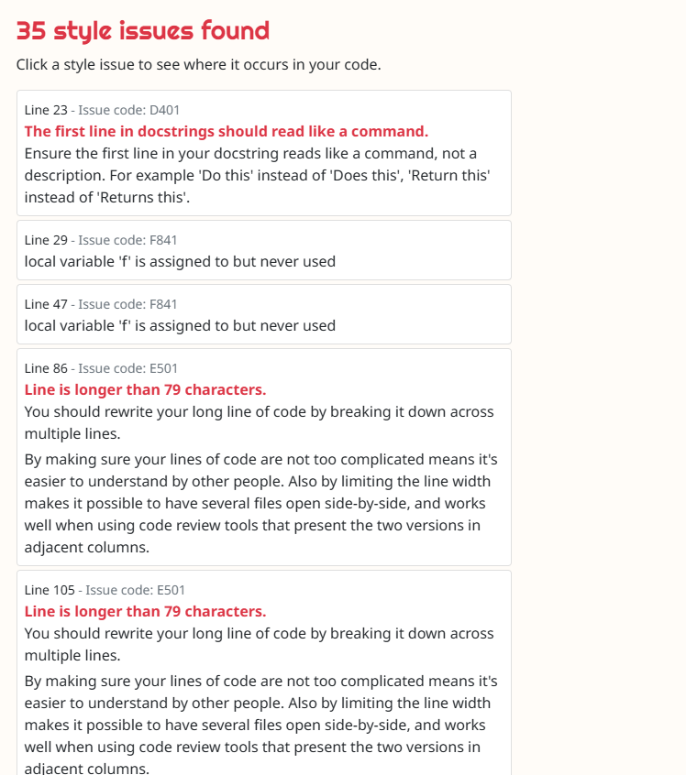

VD 1

# Barebones Working Code

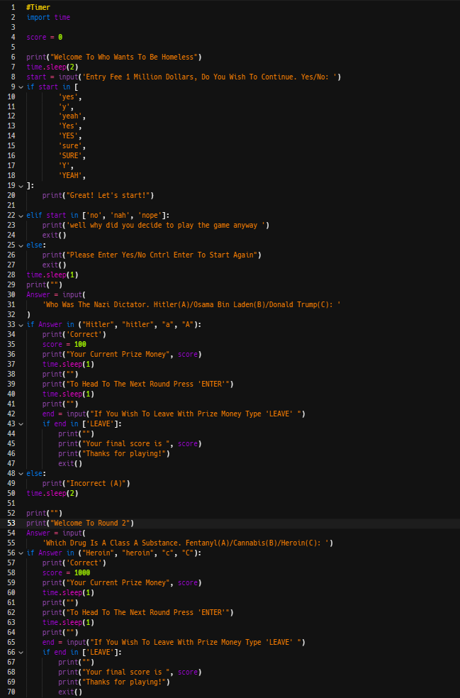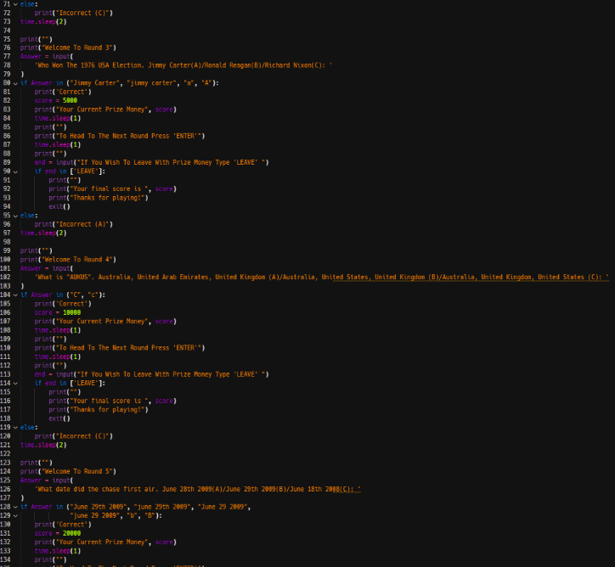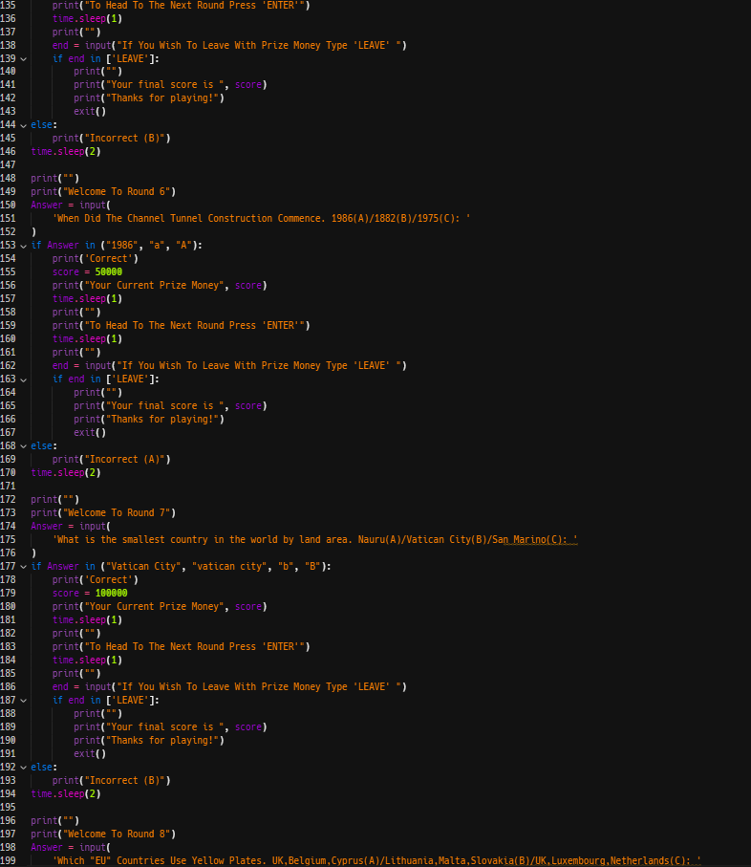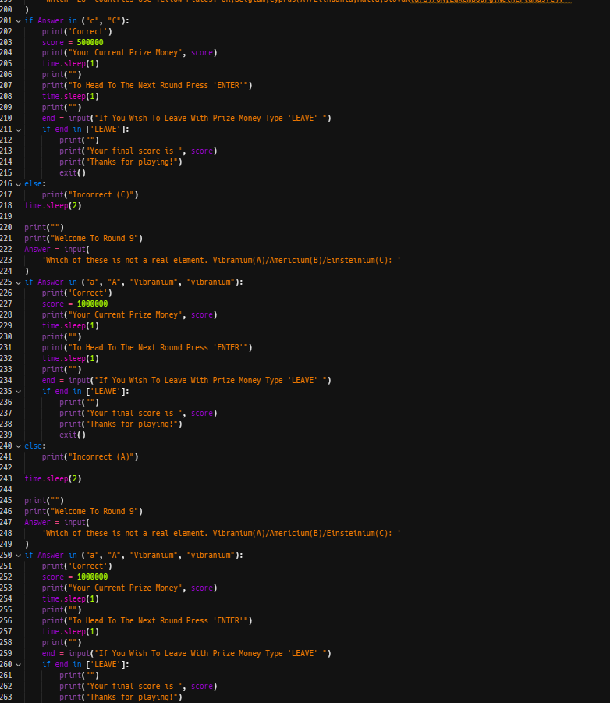

VD 2

# Added The 10th Question + Made A Ending To The Game

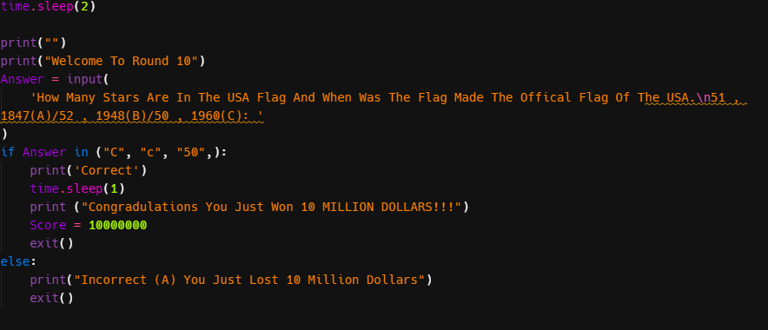

VD3

# Added A Bank Ballance With The Ability To Save And Accumulate Over Different Games With A Hidden To The User Reset Score Button

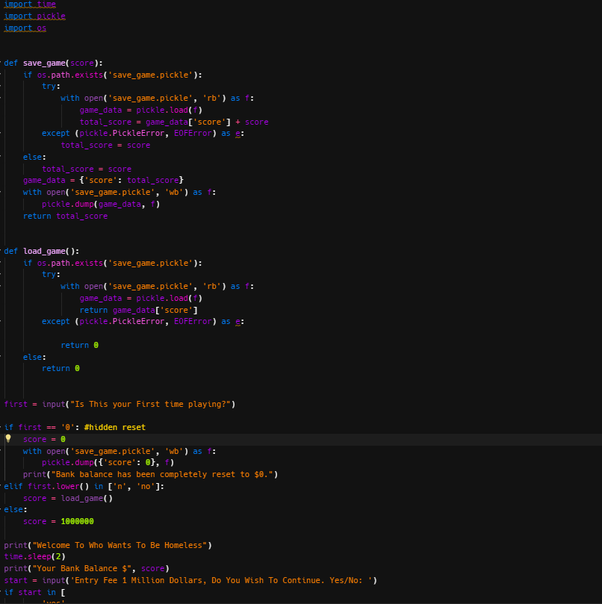

VD 4

# Added Colour To Answers

VD 5

# Added More In-depth Comments And new rules/game functions list

